**Day-6**

**1)Perform file from local Disk to Disk**

**URL- https://app.workato.com/recipes/47921059-disk_to_disk#recipe**

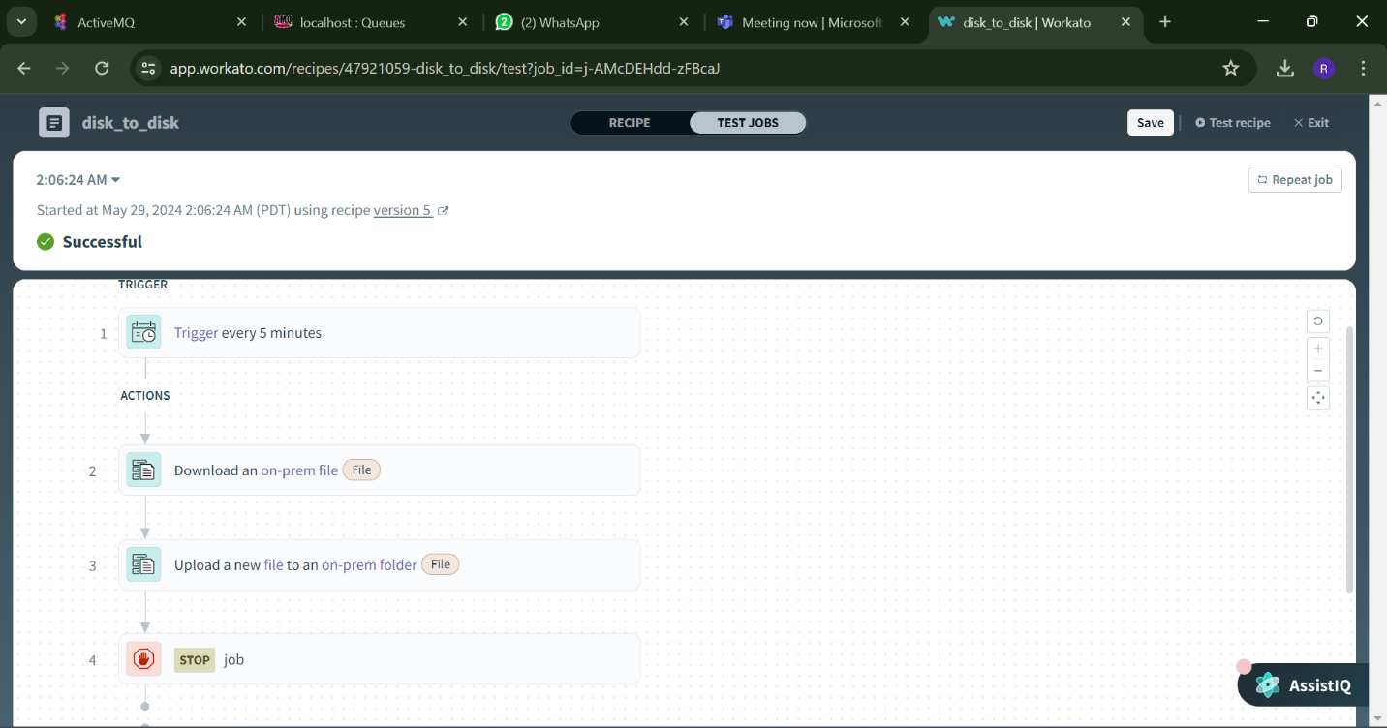

**2)Perform file from FTP to FTP**

**URL-https://app.workato.com/recipes/47914688-ftp_to_ftp#recipe**

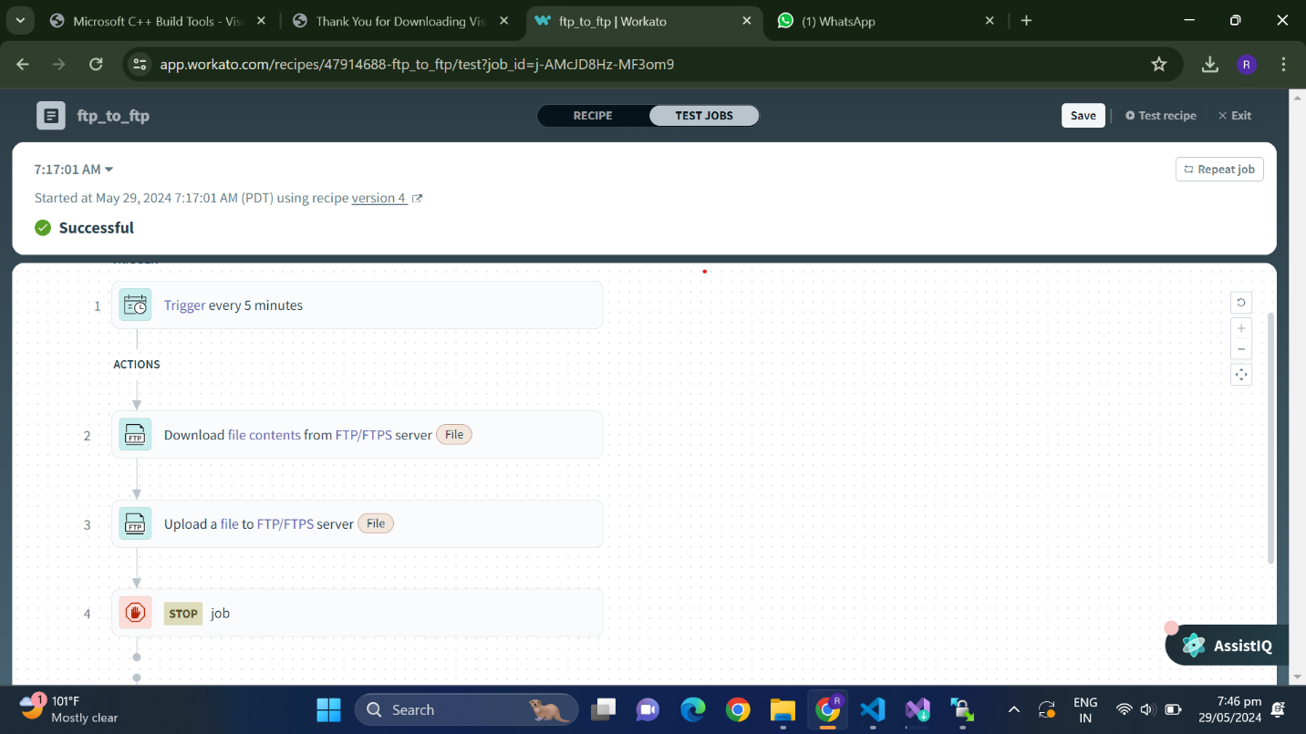

**3)Perform file from local Disk to FTP**

**URL-** [**https://app.workato.com/recipes/47937403-disktoftp#recipe**](https://app.workato.com/recipes/47937403-disktoftp#recipe)

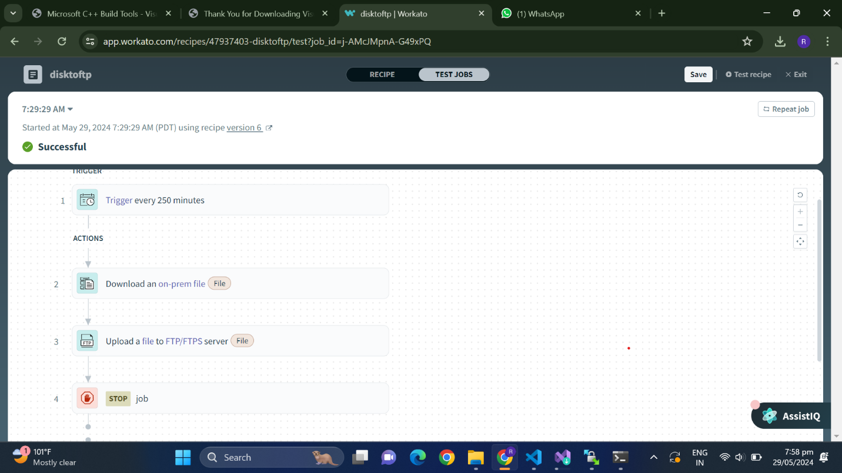

**4)Perform file from FTP to Disk**

**URL-https://app.workato.com/recipes/47937515-ftptodisk#recipe**

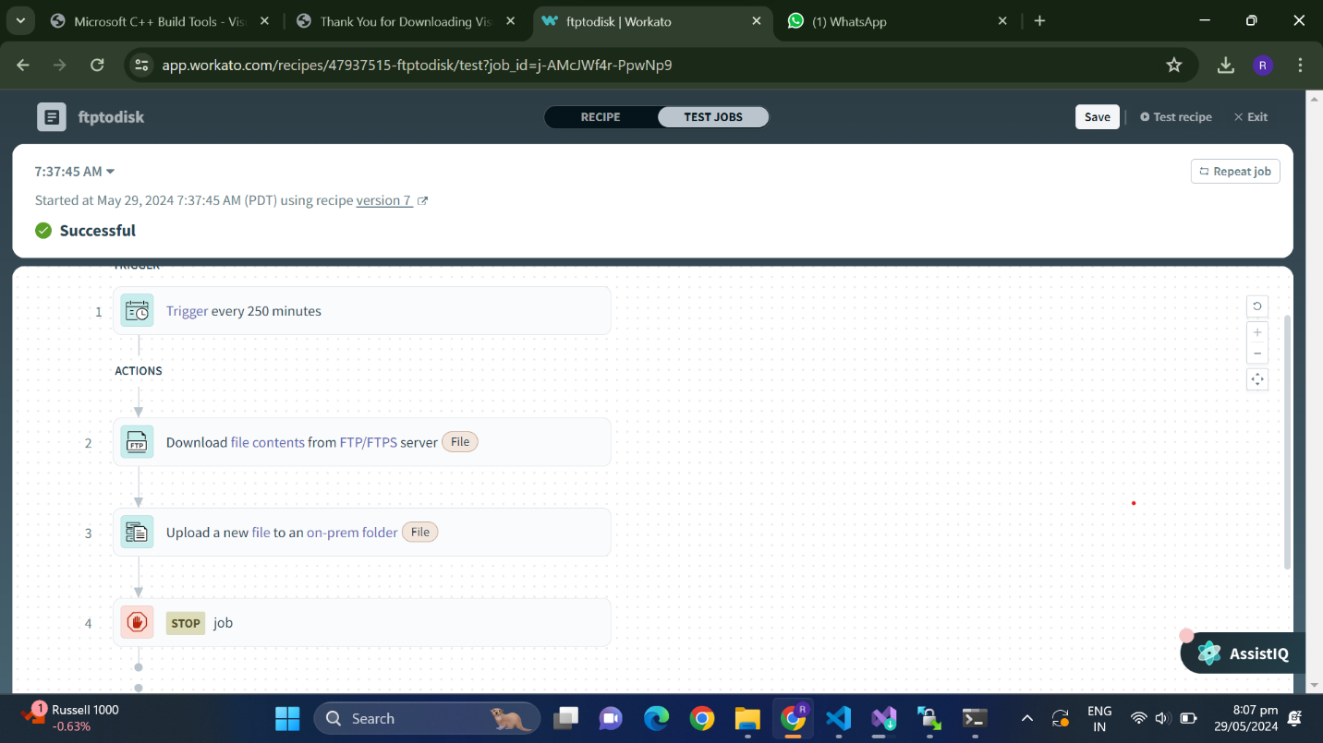

**DAY-7**

**1)File to ActiveMQ Transfer**

**URL-** [**https://app.workato.com/recipes/47925075-filetomq#recipe**](https://app.workato.com/recipes/47925075-filetomq#recipe)

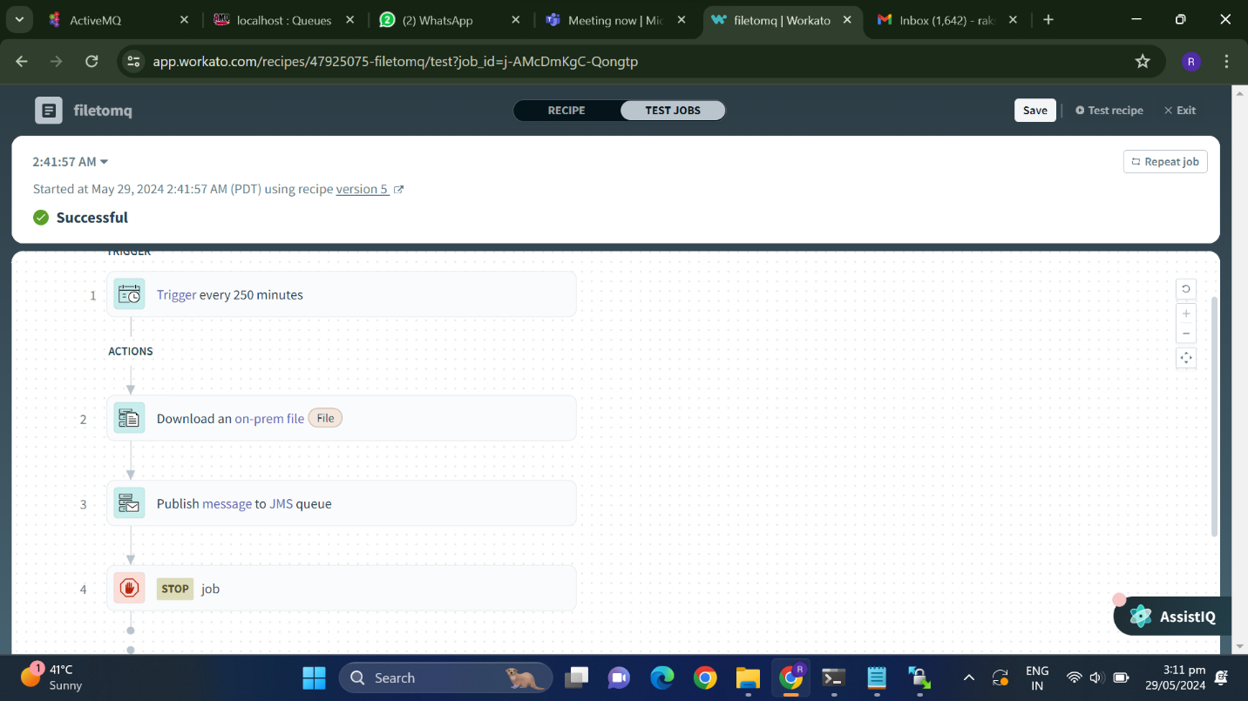

**2)ActiveMQ to FTP Transfer**

**URL-https://app.workato.com/recipes/47925219-activemqtoftp#recipe**

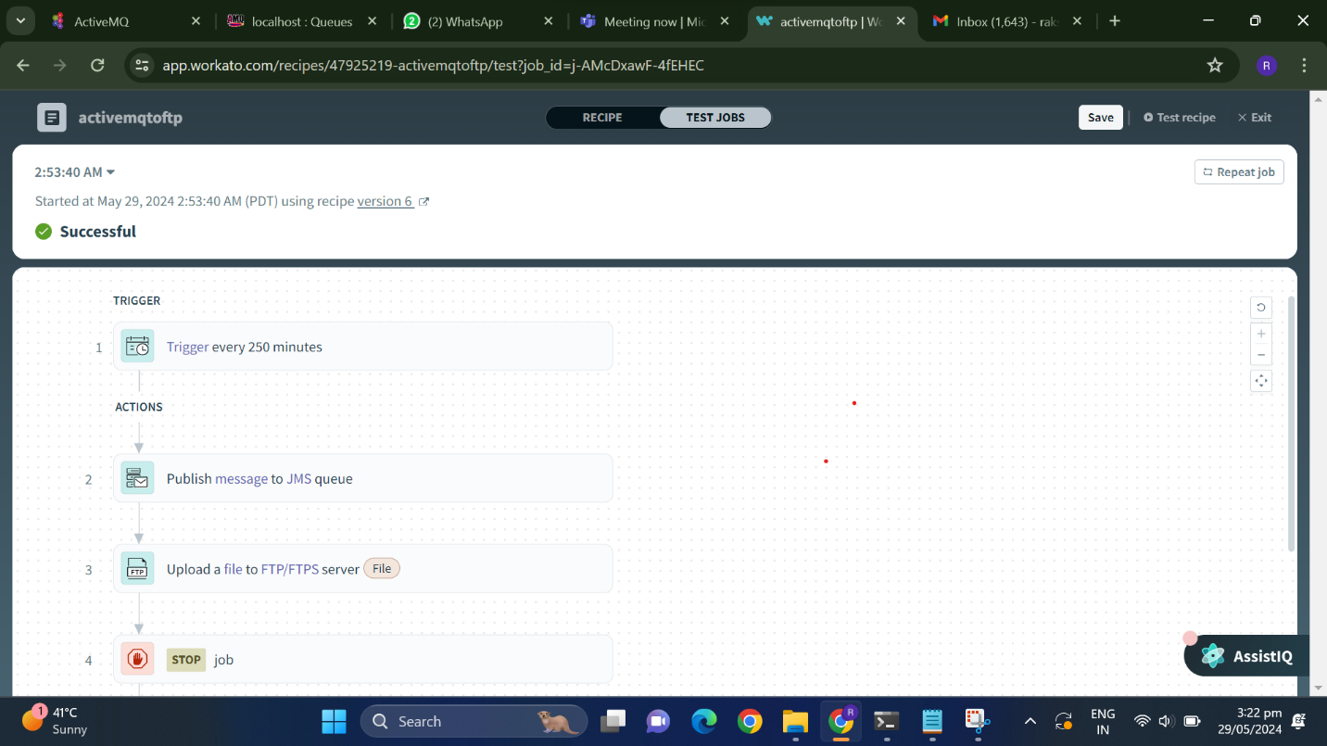

**3)ActiveMQ TO Email Transfer**

**URL- https://app.workato.com/recipes/47924098-activemqtoemail#recipe**

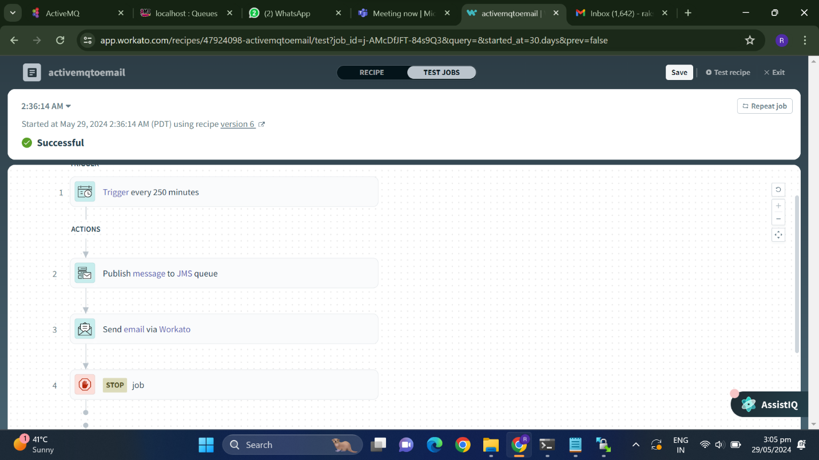

**Output:**

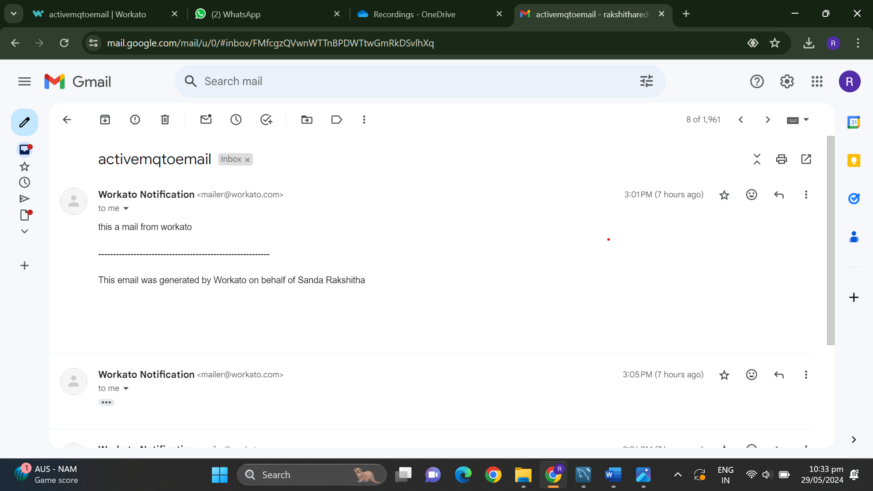

**4)File to Email Transfer**

**URL- https://app.workato.com/recipes/47923883-filetoemail#recipe**

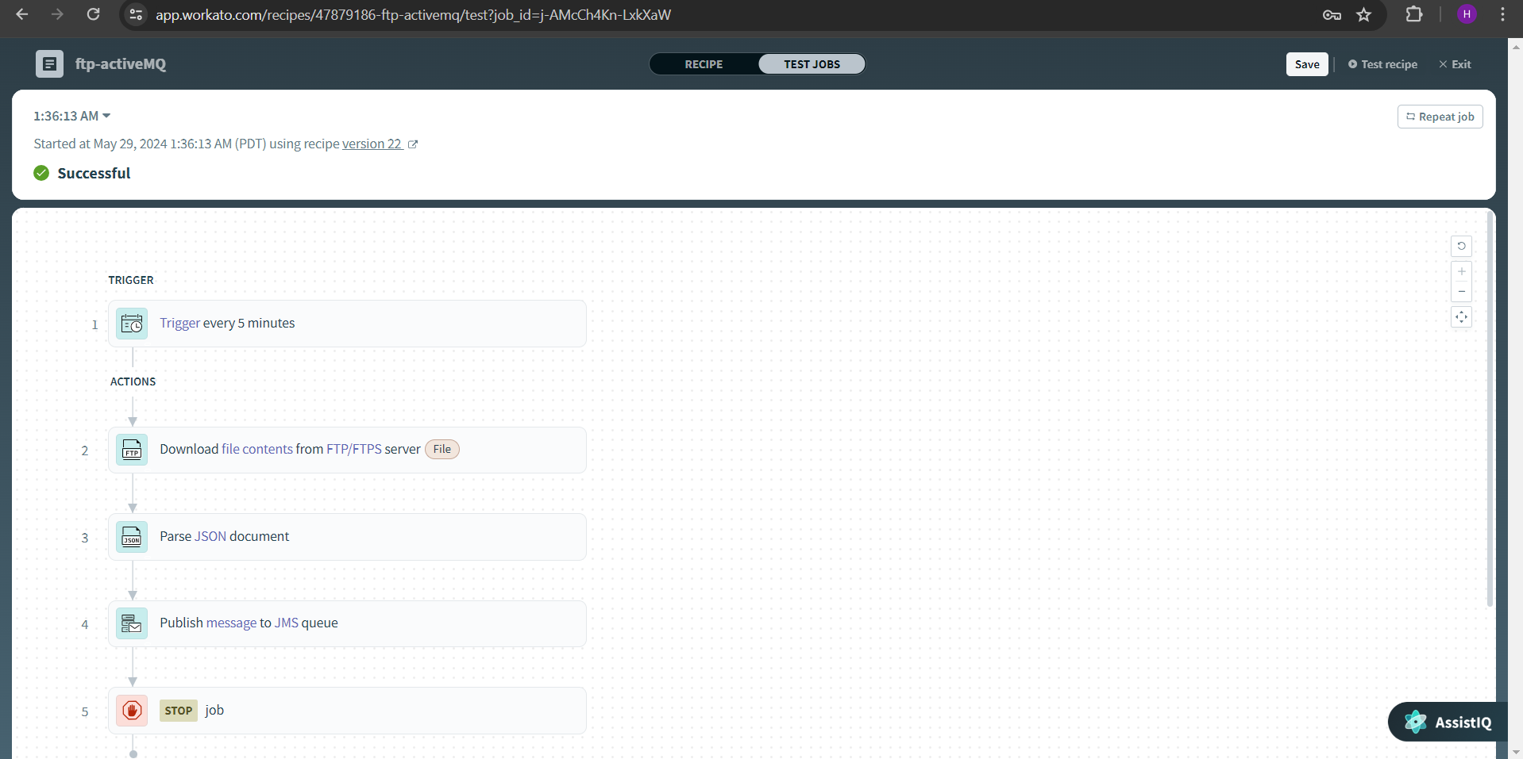

**Output:**

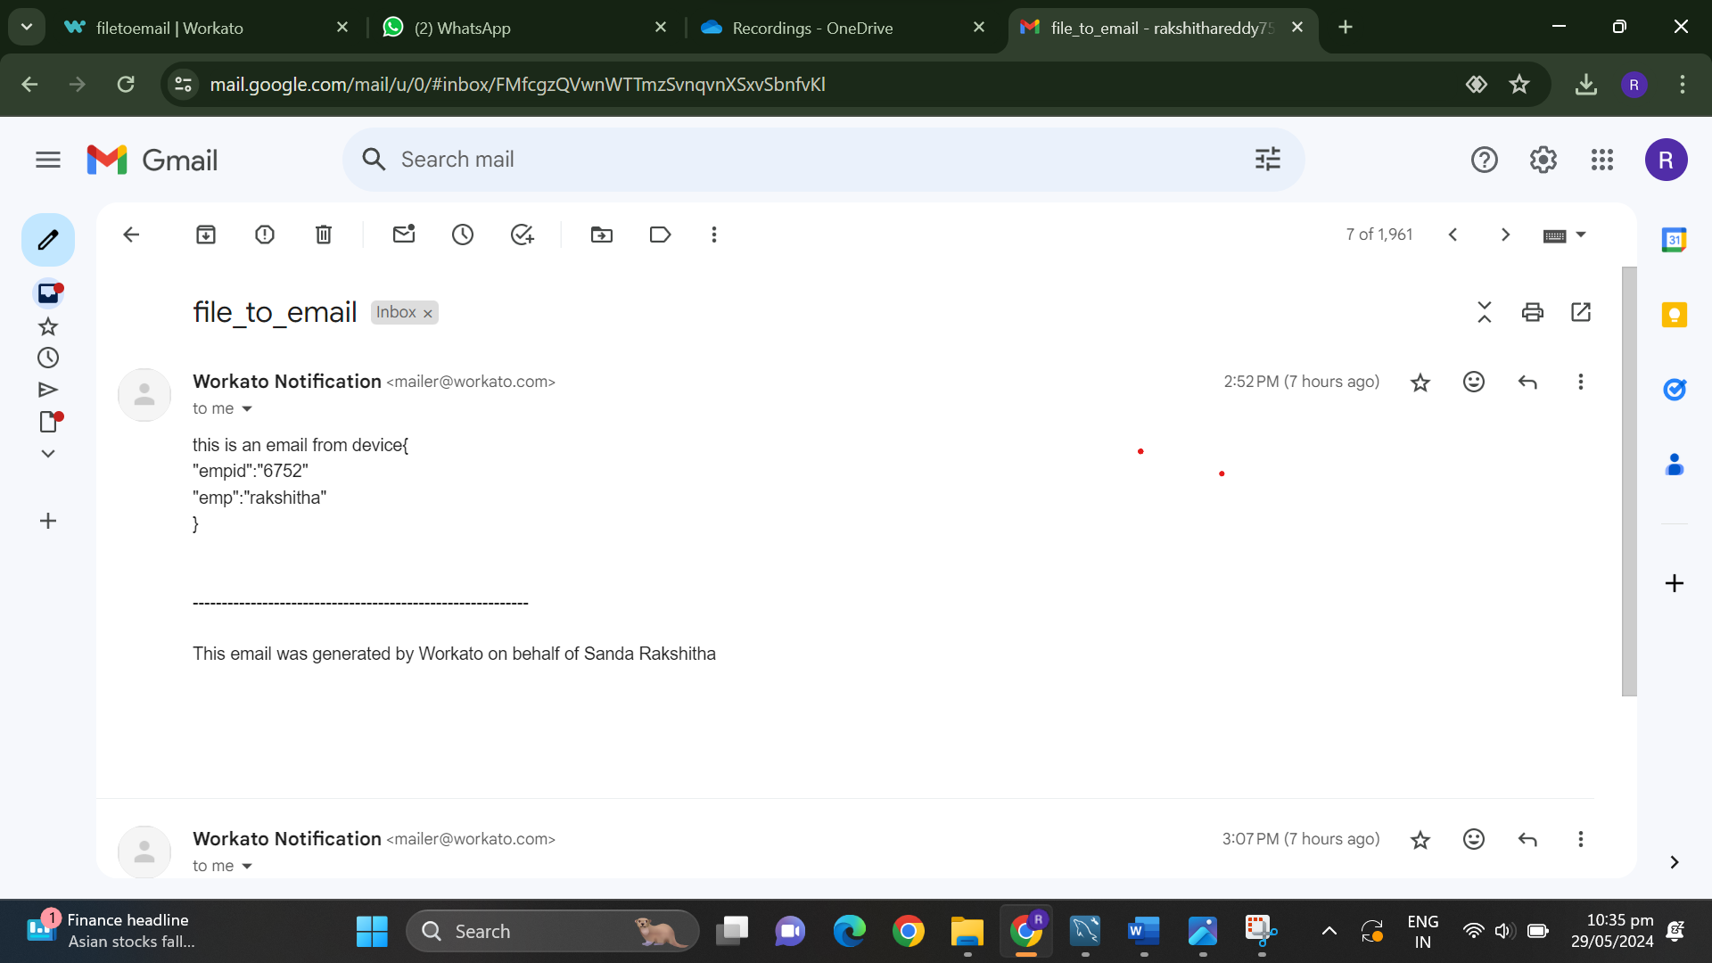

**5)Ftp to ActiveMQ Transfer**

**URL- https://app.workato.com/recipes/47925219-activemqtoftp#recipe**



**6)Ftp to Email Transfer**

**URL- https://app.workato.com/recipes/47925203-ftptoemail#recipe**

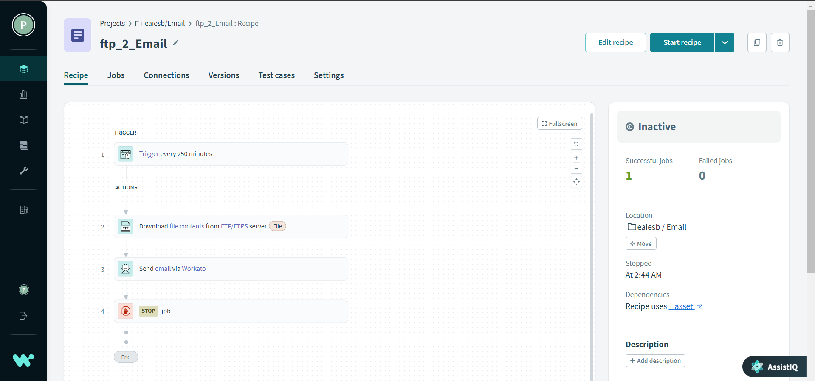

**Output:**

